Batch:______A3____ Roll No.:________1911034______
Experiment No.
Grade: AA / AB / BB / BC / CC / CD /DD

Title: Implementation of Hashing using collision resolution methods linear and quadratic probing.

Objective: To understand concept of hashing and rehashing, designing of hash function and applications of hashing.

Expected Outcome of Experiment:

CO | Outcome
CO3 | Demonstrate sorting and searching methods.

Books/ Journals/ Websites referred:
https://searchsqlserver.techtarget.com/definition/hashing#:~:text=Hashing%20is%20the%20transformation%20of,it%20using%20the%20original%20value.
https://en.wikipedia.org/wiki/Hash_function
https://www.tutorialspoint.com/data_structures_algorithms/hash_data_structure.htm

Abstract:- (Definitions of Hashing, Hash function design, collision, collision handling method )
Hashing :

Definition : Hashing is an important Data Structure which is designed to use a special function called the Hash function which is used to map a given value with a particular key for faster access of elements. The efficiency of mapping depends of the efficiency of the hash function used.
Hash Function Design :
What is a Hash Function ?
A function that converts a given big number to a small practical integer value. The mapped integer value is used as an index in the hash table. In simple terms, a hash function maps a big number or string to a small integer that can be used as the index in the hash table.
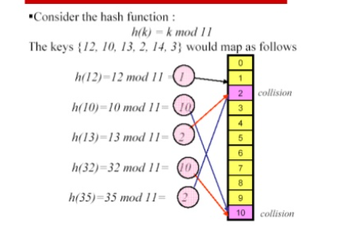
The figure shows a hash function h(k) = k mod 11, which has been used in this experiment.
Design of Hash Functions ;
At the heart of a hashing is a mathematical function that operates on two fixed-size blocks of data to create a hash code. This hash function forms the part of the hashing algorithm.
The size of each data block varies depending on the algorithm. Typically the block sizes are from 128 bits to 512 bits. The following illustration demonstrates hash function −
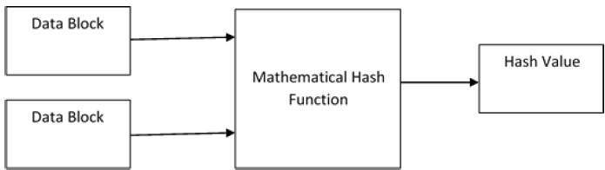
Hashing algorithm involves rounds of above hash function like a block cipher. Each round takes an input of a fixed size, typically a combination of the most recent message block and the output of the last round.

What is a collision in Hashing ?
A collision (or a clash) is a situation, when to or more values to be mapped have the same hash value.
Due to the possible applications of Hashing in computer science, Collision Avoiding has become a fundamental topic of computer science.
For example , in the above Hash Function , h(k) = k mod 11 , a collision will occur when numbers such as 11 , 22 are hashed . As 11 would be mapped to the value 0 and 22 as well , there would occur a collision.

Collision Handling Methods:
Chaining : This Technique implements a linked list , when two or more values have to be mapped to the same hash value , then those values are stored in the form of a linked list.
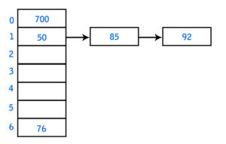

For example , here 85 and 92 have to be stored in the same index as that of 50 , thus they’re actually stored in a linked list , chained to 50.

Open Addressing ;
Like separate chaining, open addressing is a method for handling collisions. In Open Addressing, all elements are stored in the hash table itself. So at any point, the size of the table must be greater than or equal to the total number of keys
Open addressing is done in the following ways ;
Linear probing:
- Linear Probing is a component of open addressing schemes for using a hash table for resolving collisions.
- The linear probing table is a fairly simple structure in which data items are stored directly in the hash-element array. It gets it’s name by the way it handles the unique problems that exist when storing the data items in the array directly.
- It takes constant expected time , per insertion search or deletion , when implemented using a linear hash function.
- To insert a key value pair (x,v) into the hashing table , the insertion algorithm follows the same sequence of cells as would be followed for search , until finding an empty cell or a cell whose stored key is x

Quadratic Probing :
In open addressing scheme, the actual hash function h(x) is taking the ordinary hash function h’(x) and attach some another part with it to make one quadratic equation.
h´ = (𝑥) = 𝑥 𝑚𝑜𝑑 𝑚
ℎ(𝑥, 𝑖) = (ℎ´(𝑥) + 𝑖²)𝑚𝑜𝑑 𝑚
We can put some other quadratic equations also using some constants
The value of i = 0, 1, . . ., m – 1. So we start from i = 0, and increase this until we get one free space. So initially when i = 0, then the h(x, i) is same as h´(x).

Types of Hash functions:

MD5 Hash function :
- The MD5 message-digest algorithm is a widely used hash function producing a 128-bit hash value.
- Although MD5 was initially designed to be used as a cryptographic hash function, it has been found to suffer from extensive vulnerabilities
- MD5 operates on 32-bit words. Let M be the message to be hashed. The message M is padded so that its length (in bits) is equal to 448 modulo 512, that is, the padded message is 64 bits less than a multiple of 512. The padding consists of a single 1 bit, followed by enough zeros to pad the message to the required length. Padding is always used, even if the length of M happens to equal 448 mod 512. As a result, there is at least one bit of padding, and at most 512 bits of padding. Then the length (in bits) of the message (before padding) is appended as a 64-bit block.

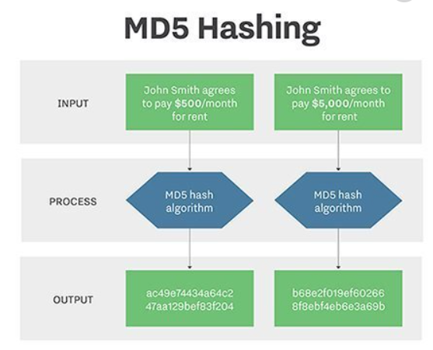

Example of MD5 Hashing of a message

Whirlpool Hash Function ;
This is a 512-bit hash function.
- It is derived from the modified version of Advanced Encryption Standard (AES). One of the designer was Vincent Rijmen, a co-creator of the AES.
- Three versions of Whirlpool have been released; namely WHIRLPOOL-0, WHIRLPOOL-T, and WHIRLPOOL.

SHA Hash Functions :
Family of SHA comprise of four SHA algorithms; SHA-0, SHA-1, SHA-2, and SHA-3. Though from same family, there are structurally different.
- The original version is SHA-0, a 160-bit hash function, was published by the National Institute of Standards and Technology (NIST) in 1993. It had few weaknesses and did not become very popular. Later in 1995, SHA-1 was designed to correct alleged weaknesses of SHA-0.
- SHA-1 is the most widely used of the existing SHA hash functions. It is employed in several widely used applications and protocols including Secure Socket Layer (SSL) security.

RIPEMD
The RIPEMD is an acronym for RACE Integrity Primitives Evaluation Message Digest. This set of hash functions was designed by open research community and generally known as a family of European hash functions.
- The set includes RIPEMD, RIPEMD-128, and RIPEMD-160. There also exist 256, and 320-bit versions of this algorithm.
- Original RIPEMD (128 bit) is based upon the design principles used in MD4 and found to provide questionable security. RIPEMD 128-bit version came as a quick fix replacement to overcome vulnerabilities on the original RIPEMD.
- RIPEMD-160 is an improved version and the most widely used version in the family. The 256 and 320-bit versions reduce the chance of accidental collision, but do not have higher levels of security as compared to RIPEMD-128 and RIPEMD-160 respectively.

Methods of collision resolution :
The methods of collision resolution are :
Chaining (as described above )
And Open addressing , which includes linear and quadratic probing as descried above.
Hash Function chosen for experiment:
- The hash function chosen for this experiment was h(k) = (k)mod(11), where k is the function to be mapped to the hash table.
Program Source Code :
#include <stdio.h>

int insert(int a[],int num,int ch)
{

int index,count=0;
index = num%11;
if(a[index]==-1)
{
a[index]=num;
printf("element is inserted at index %d\n",index );

}
else while(a[index]!=-1)
{
index = (index+1)%11;
count++;
if((a[index]==-1)||(count==10))
break;
}
if(a[index]==-1)
{
a[index]=num;
printf("element is inserted at index %d\n",index );
}
else if(count==10)
{
printf("array is full");
index =-1;
}
{

}
return count;
}
void display(int a[])
{
int i;
for(i=0;i<11;i++)
{
printf("%d\n",a[i]);
}
}

void search(int a[],int num)
{
int index,count=0;
index = num%11;
if (a[index]==num)
{
printf("element exists\n");
}
else while(a[index]!=num)
{
index = (index+1)%11;
count++;
if((a[index]==-1)||(count==10))
{
printf("element not found\n");
break;
}
else if(a[index]==num)
{
printf("element found at index %d\n",index);
}

}
}
int main(void) {
printf("Hello World\n");
int col=0;
int a[11],n,i,c,ch;
int num;
for(i=0;i<11;i++)
{
a[i]=-1;
}

printf("Enter the number of elements (less than or equal to 11)\n");
scanf("%d",&n);
printf("Enter the elements\n");
for(i=0;i<n;i++)
{
scanf("%d",&num);
c=insert(a,num,n);
col=col+c;

}
do
{printf("Enter any of the following options\n");
printf("Enter 1 to insert an element\n");
printf("enter 2 to display\n");
printf("enter 3 to display total number of collisions so far\n");
printf("enter 4 to search for an element\n");
printf("enter -1 to exit\n");
scanf("%d",&ch);
switch(ch)
{
case 1:
{
printf("enter the element\n");
scanf("%d",&num);
c=insert(a,num,n);
col = col+c;
}
break;
case 2:
{
display(a);
}
break;
case 3:
{
printf(" total number of collisions so far:%d\n",col);
}
break;
case 4:
{
printf("enter the element you want to search\n");
scanf("%d",&num);
search(a,num);
}
}
}while(ch!=-1);

return 0;
}

Output Screenshots :
Inserting the elements into the Hash Table
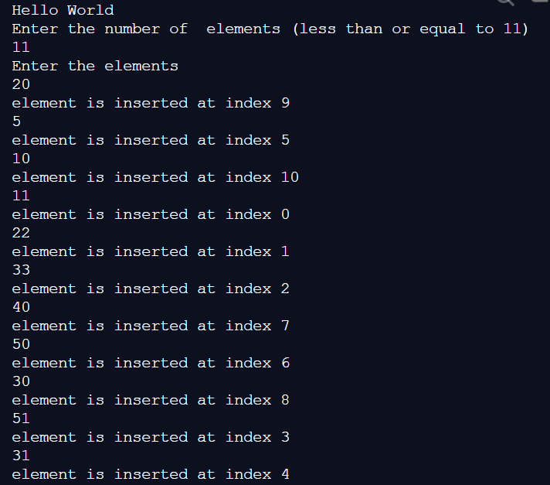
Displaying the total number of collisions ;
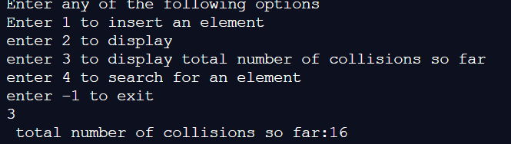
Displaying the elements after being inserted into the Hash Table
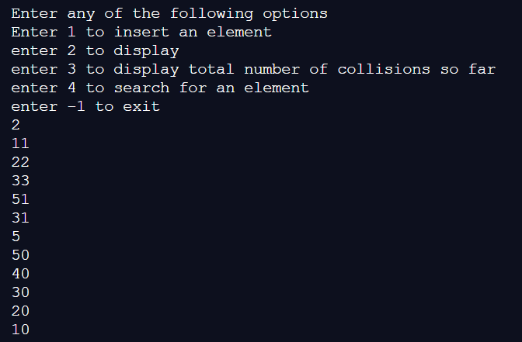
Inserting new elements into the Hash table (lesser than the max capacity) (-1 denotes those places in the array that haven’t been assigned with a hash value)
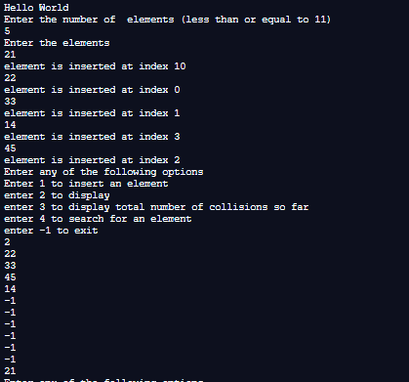
After inserting the 6th element , new hash table looks as follows :

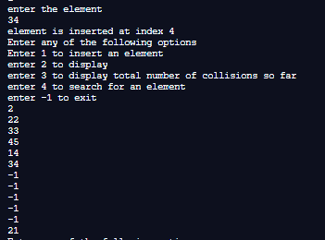
Searching whether a particular element exists or not :
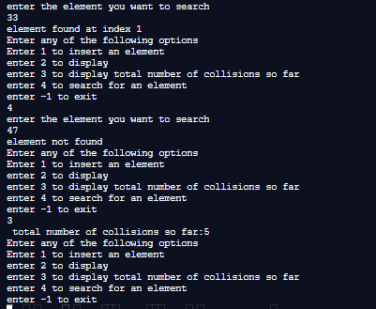

Implementation Details:
- Enlist all the Steps followed and various options explored

Steps Followed :
- First , the number of elements (less than or equal to 11) are accepted by the user.
- Then we accept the actual values and pass them to the function ‘insert’ which uses the function h(k)= k%11, where k is the element to be inserted and h(k) gives the index at which it is inserted.
- In the insert function , we insert the elements one by one into the hash table using the hashing function , as described above.
- If there occur any collision , they are then resolved using the linear probing technique , i.e. if h(k) = index , and if a[index] is already occupied by another element then we set index = (index+1)%11 and insert the element at that index.
- This process is repeated until we find that either the hash table is full or the element is insert.
- A counter ‘col’, keeps track of the number of collisions for each insert operation , and they are simultaneously added to another variable in the main function which keeps the total track of all the collisions for all the insert operations.
- For searching operation ,we follow a similar procedure, i.e , we keep searching until either we find the element , or until a variable count , gets incremented to the value which will be the max size of the array , indicating that the element is not present .

Options explored:
- There are many options for resolving collisions in a hash table. Some of them are linear probing , quadratic robing and chaining. Here we have explored the linear probing technique for resolving collisions.
- The variable that keeps track of the total number of collisions can be implemented either in the insert function or in the main function , here we have implemented it in the main function

- Explain your program logic, classes and methods used.

Program logic used :

Algorithm Used (for insertion)
Let a[] represent the array which represents the hash table where the elements are inserted.
Step1: accept the number of elements to be entered from the user.
Step2 : accept the elements , one by one , by passing them to a function insert() , which returns the number of collisions that occur when inserting an element.
Step3: store the number of collisions for each insert operation for all the elements to be inserted in the calling function.
Step4 :In the insert function ,set count=1,col =0 find the value of num % 11 and store it in a variable ‘index’.
Step5 : if a[index] = -1 , then set a[index]= num , else repeat step 6 while a[index]!=-1 OR count !=10
Step6: if(a[index]=-1), set a[index]=num , and break. Else set ,
index = (index+1)%11 , and set count = count+1, set col = col+1.
Step 7: if (count==10), then the hash table is full and the element cannot be inserted. Else return the number of collisions that occurred while inserting the element to the main function.
Algorithm used (for searching)
Let ‘num’ be the element to be searched for in the hash table.
Step1: In the search function, pass the element to be searched by accepting it in the main function.
Step 2: in the search function, set count=0 , set index = num%11, if a[index]==num , print ‘element found’, else repeat step 3 while, count!=10 , OR while a[index]!=num.
Step3: if(a[index]==num), print (‘element found’) and exit while loop. Else set count= count+1.
[END OF WHILE].
Step4: if count =10, print (‘element does not exist’)

Methods used :
int insert (int a[], int num, int ch) : used to insert any element into the hash table.
int search (int a[], int num) : used to search if any element is present in the hash table.
Classes used : no classes were used.

3. Explain the Importance of the approach followed by you

In this approach :
- We have learnt how to make use of a simple hash function , for storing elements in a hash table that makes it easier to search for them , as opposed to searching for an elements in a simple array , which takes linear time.
- We have learnt to design a hash function h(k) = k%n, where n should be at least equal to the size of the array in which the elements are stored, and we have learnt the importance of using ‘n’ as a prime number as it helps to generate more unique hashes for the elements.
- We have used the linear probing technique , which is one of the open addressing methods that are used for resolving collisions.
- We have implemented a search function , which takes lesser time , for searching as compared to a simple linear search , as the value of each element , is linked to it’s position in the hash table.

Postlab questions-
- Store the given numbers in bucket of size 16, resolve the collisions if any with
  - Linear probing
  - Quadratic hashing
  - Chaining
20, 33, 65, 23, 11, 32, 78, 64, 3, 87, 10, 7

Linear probing :

20%16 = 4, a[4]= 20

33%16 =1, a[1]=33

65 %16 = 1, (1+1)%16 = 2, a[2] = 65

23%16 = 7 , a[7]=23

11%16 = 11, a[11]=11

32%16 = 0, a[0] = 32

78%16 = 14, a[14] = 78

64 %16 = 0 , (0+1)%16 = 1, (1+1)%16 = 2, (2+1)%16 = 3, a[3] = 64

3%16 = 3, (3+1)%16 = 4, (4+1)%16 = 5, a[5] = 3

87%16 = 7, (7+1)%16 = 8, a[8] = 87

10 % 16 = 10 , a[10] =10

7%16 = 7 , (7+1)% 16 = 8, (8+1)%16 = 9, a[9]=7

32 | 33 | 65 | 64 | 20 | 3 |  | 23 | 87 | 7 | 10 | 11 |  |  | 78
0 1 2 3 4 5 6 7 8 9 10 11 12 13 14 15

Quadratic Hashing :

32 | 33 | 65 | 3 | 20 |  | 7 | 23 | 87 | 64 | 10 | 11 |  |  | 78
0 1 2 3 4 5 6 7 8 9 10 11 12 13 14 15

20, 33, 65, 23, 11, 32, 78, 64, 3, 87, 10, 7

20%16 = 4, a[4]= 16

33%16 = 1, a[1]=33

65%16 = 1 , a[1]= 65 (through chain)

23%16 =7 , a[7] = 23

11%16 = 11, a[11] = 11

32%16 = 0, a[0] = 32

78%16 = 14 , a[14]= 78

64%16 =0 , a[0] = 64 (through chain)

3%16 = 3, a[3] = 3

87%16 = 7 , a[7] = 87 (trough chain)

10%16 = 10, a[10] = 10

7%16 = 7 , a[7] = 7 (through chain)

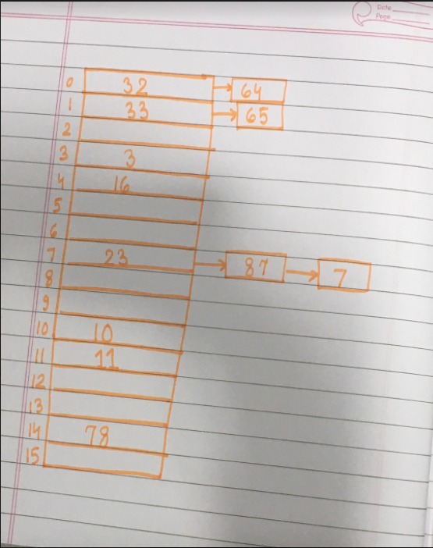

Conclusion:- In this experiment , we have learnt about , Hashing as an efficient way to store data , in a way that maps each key to a hash value , thus decreasing the time required for the search operation. We have also learnt what is collision in hashing and how collisions are resolved using the various techniques like linear probing, quadratic probing and chaining.

